Section I
Introduction: Ergonomics and Risk Management

Ergonomics is the scientific discipline concerned with the understanding of interactions among people and other elements of a system to optimize their well-being and overall system performance [IEA 2008]. This is generally accomplished by applying ergonomic principles to the design and evaluation of manual tasks,' jobs, products, environments, and systems, ensuring that they meet the needs, capabilities, and limitations of people. When integrated with safety and health programs, ergonomics can be viewed as a third leg of a three-pronged risk management approach to reduce musculoskeletal disorder (MSD) rates. Safety focuses on hazards that may result in traumatic injuries, industrial hygiene concentrates on hazards that may cause occupational disease, and ergonomics addresses risk factors that may result in MSDs and other conditions, such as vibration-related illnesses. By applying ergonomic principles to the workplace with a systematic process, risk factor exposures are reduced or eliminated. Employees can then work within their abilities and are more efficient at performing and completing tasks. The benefits of applying ergonomic principles are not only reduced MSD rates, but also improved productivity and quality of life for workers.
The purpose of this document is to provide information on implementing a successful ergonomics process that is part of the organizational culture. Section I describes the basic elements of the process and then discusses the importance of employee participation in the implementation of the process. Also included in this section is information on the evolution of risk management as it applies to an ergonomics process. A model developed for safety and health risk management defines five stages, ranging from a pathological stage to a generative stage from a stage that attributes safety problems to employees to one that involves all employees in risk management at multiple levels with the goal of promoting the well-being of employees. Section II describes how three mining companies implemented ergonomics processes, including lessons learned. Interventions implemented by the mining companies are presented in Section III, along with information on changes to discomfort levels at one of the companies. Section IV describes various tools used when implementing the processes, while Section V focuses on

^{l}Manual tasks are tasks that involve lifting, pushing, pulling, carrying, moving, manipulating, holding, pounding, or restraining a person, animal, or item.

training, including a presentation for management that promotes the value of ergonomics processes. The tools presented in Section IV and the management presentation contained in Section V are provided as electronic files on the CD included with this document.

Basic Elements of Ergonomics Risk Management Processes

Successful ergonomics risk management processes have several elements in common. The process starts with establishing an understanding of the task and interactions that occur between the worker and equipment, tools, work station used to complete the task, and work area/environment in which the task is conducted. Managing risks associated with manual tasks requires identifying risk factor exposures. If the exposures cannot be eliminated, the degree and source of risk requires assessment. Potential controls or interventions are then identified, evaluated, and implemented to reduce the risk as far as reasonably practical.
The ultimate aim of an ergonomics risk management process is to ensure that all tasks performed in workplaces can be performed with dynamic and varied movements of all body regions with low to moderate levels of force, comfortable and varied postures, no exposure to whole-body or hand-arm vibration, and breaks taken at appropriate intervals to allow adequate recovery.

Element 1: Identifying Risk Factor Exposures During Manual Tasks
Identification of risk factor exposures should include consultation with employees, observation of manual tasks, and/or review of workplace records. Employees should be asked what they think is the most physical part of their job or what task is the hardest to do. Conditions that could potentially indicate risk factor exposures include the following:

- An MSD was associated with performance of the task.
- Any employee is physically incapable of performing the task.
- The task can only be done for a short time before stopping.
- The mass of any object being handled exceeds 35 pounds.
- The postures adopted to perform the task involve substantial deviations from neutral, such as reaching above shoulders, to the side, or over barriers; stooping; kneeling; or looking over shoulder.
- The task involves static postures held for longer than 30 seconds and is performed for more than 30 minutes without a break or for more than 2 hours per shift.
- The task involves repetitive movements of any body part and is performed for more than 30 minutes without a break or for more than 2 hours per shift.
- The task is performed for more than 60 minutes at a time without a break.
- The task is performed for longer than 4 hours per shift.
- Any employee reports discomfort associated with the manual task.
- An employee is observed having difficulty performing the manual task.
- Employees have improvised controls for the task (e.g., phone books for footstools, use of furniture other than that provided for the task).
- The task has a high error rate.
- Workers doing this task have a higher turnover, or rate of sick leave, than elsewhere in the organization.
- Exposure to whole-body vibration (vehicles) or arm-hand vibration (power tools) exceeds 2 hours per shift.

NOTE: The conditions listed above were compiled by the authors based on their professional knowledge and from various sources, such as the Washington State Hazard and Caution Zone Checklists [Washington State Department of Labor and Industries 2008a,b] and limits used for medical restrictions and other guidelines. These conditions alone do not necessarily indicate a risk factor exposure, nor do they indicate a boundary between safe and unsafe conditions. Rather, they must be evaluated in terms of the worker and all aspects of the task: methods or work practices, equipment, tools, work station, environment, duration, and frequency.

If after adequate consultation, observation, and review of records, none of the above conditions is met for any manual tasks in a workplace, then it is reasonable to conclude that the manual tasks are likely to constitute a low MSD risk. For each manual task that has been identified as requiring assessment (one or more of the above conditions is identified), it is sensible to ask whether the task can be easily eliminated. If the manual task can be eliminated, and this is done, then there is no need for an analysis. Reassessment should be conducted whenever there is a change in equipment or work processes. Any new MSD or report of discomfort that is associated with any manual task should trigger either elimination of the task or a risk assessment.

Element 2: Assessing MSD Risks for Manual Tasks

If risk factor exposures exist that cannot be eliminated, the next step is to assess the risks. The aim of the risk assessment is to assist the risk control process by providing information about the root causes and severity of the risk. The assessment should be undertaken with the involvement of the workers who perform the tasks. The assessment of exposures is complicated by the number of exposures that contribute to determining the MSD risk and by the interactions among the different risk factors. The risk assessment process is also complicated by the number of body parts that can be affected and by the variety of possible ways in which an MSD may occur. MSDs occur when the forces on a body tissue (muscle, tendon, ligament, and bone) are greater than the tissue can withstand. MSDs do not occur suddenly as a consequence of a single exposure to a force. They arise gradually as a consequence of repeated or long-duration exposure to lower levels of force. Even low levels of force can cause small amounts of damage to body tissues. This damage is normally repaired before an MSD occurs. However, if the rate of damage is greater than the rate at which repair can occur, an MSD may result. MSDs may also result from a combination of these mechanisms, e.g., a tissue that has been weakened by cumulative damage may be vulnerable to sudden injury at lower forces. Also, if a tissue has suffered a sudden injury, it may be more prone to an MSD-type injury during its recovery process. Manual task risk assessment needs to consider these possible mechanisms. MSDs associated with manual tasks can occur to a range of different parts of the body, and the injury risks associated with a task will vary for different body regions. Consequently, the degree of exposure to different risk

factors must be assessed independently for different body regions. In addition to the forces involved, the risk of an MSD to a body part depends on the movements and postures involved, the duration of the exposure, and whether there is exposure to vibration. The risk assessment must address each of these risk factors and the interactions between them.
The first step in assessing the risk of an MSD associated with a particular manual task is to determine the body regions of interest. This may be self-evident if the task has already been identified as causing MSDs or discomfort to a particular body part or parts. Alternatively, the risk assessment should consider the risk of an MSD to each of the following regions independently: lower limbs, back, neck/shoulder, and elbow/wrist/hand. MSDs are most likely to occur when significant exposure to multiple risk factors occurs. Primary risk factors include forceful exertions, awkward postures, static posture, repetition, and vibration. Combining these risk factors greatly increases the risk for developing an MSD. Each of these risk factors is described briefly below.

Forceful Exertions
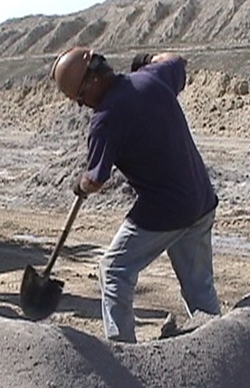
An important factor in determining the likelihood of an MSD to a specific body part is how much force is involved. Historically, the mass of objects being handled has been the focus. However, the risk associated with a task depends on a number of other factors as well. For example, in lifting and lowering tasks, the force required by the back muscles can depend on the distance of the load from the body as well as the mass of the load. Similarly, if the task involves pushing or pulling a load, the force involved will depend on the frictional properties of the load and the surface, along with the mass of the load.
Other manual tasks may not involve the manipulation of any load, but high forces can still be required. If the force exerted by a body part is close to its maximum, the worker is exposed to a high risk of a sudden MSD, and urgent action is indicated. Even if the forces involved are not close to maximum, the task may pose a high risk of an MSD if the body part is also exposed to other risk factors.

High-speed movements (hammering or throwing) are an indication of elevated risk, mostly because high speed implies high acceleration, which in turn implies high force, especially if the speed is achieved or stopped in a short time. Such "jerky" movements are an indication of initial high exertion of the body parts involved. This also includes rapid changes in the direction of movement. Another high-force situation occurs when impact force is applied by the hand to strike an object or surface. In this case, there is a high force applied to the hand by the object or surface being struck.
The magnitude of the force relative to the capabilities of the body part is what is important in assessing MSD risks. For example, the small muscles of the hand and forearm may be injured by relatively small forces, especially if the task is executed at extremes of the range of movement at a joint. This also implies that the capability of the individual performing the work must be taken into consideration when assessing the MSD risk. Overexertion depends on the magnitude of the force relative to the capabilities of the structures.

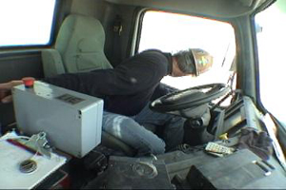
Awkward Postures
The body postures used during a task influence the likelihood of an MSD in a number of ways. If joints are exposed to postures that involve range of movement near the extreme positions, the tissues around the joint are stretched and the risk of an MSD is increased. Ligaments, in particular, are stretched in extreme postures. If the exposure to extreme postures is prolonged, the ligaments do not immediately return to their resting length afterwards. Tissue compression may also occur with extreme postures. For example, extreme postures of the wrist increases the pressure within the carpal tunnel, resulting in compression of the median nerve as it passes through the carpal tunnel.
The following list provides examples of awkward postures that may involve range of movement near extreme positions [Washington State Department of Labor and Industries 2008a,b; OSHA 1995]:
- Neck flexion (bending neck forward greater than 30°)
- Raising the elbow above the shoulder
- Wrist flexion greater than 30°
- Back flexion greater than 45°
- Squatting

Other joint postures are known to be associated with increased risk of discomfort and MSDs. These include:
- Trunk rotation (twisting)
- Trunk lateral flexion (bending to either side)
- Trunk extension (leaning backward)
- Neck rotation (turning head to either side)
- Neck lateral flexion (bending neck to either side)
- Neck extension (bending neck backwards)
- Wrist extension (with palm facing downward bending the wrist upward)
- Wrist ulnar deviation (with palm facing downward bending the wrist outward)
- Forearm rotation (rotating the forearm or resisting rotation from a tool)
- Kneeling

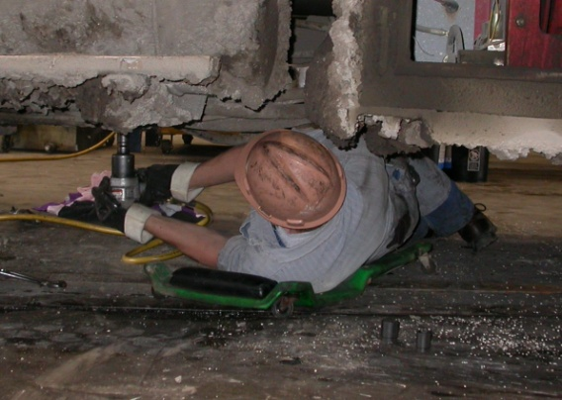
There are other awkward postures that increase the risk of an MSD because of the orientation of the body with respect to gravity and do not necessarily involve extreme ranges of movement. These postures usually require the worker to support the weight of a body part. An example would be lying under a vehicle to complete a repair. When assessing postures, it is important to note that workers of different sizes may adopt very different postures to perform the same task.
The force exertion of muscles is also influenced by the posture of the joints over which they cross. Muscles are generally weaker when they are shortened or lengthened. This effect will be greatest when the joints approach the extremes of the range of movement. Consequently, the optimal design of work aims to provide tasks that can be performed while maintaining neutral postures. The following are descriptions of neutral postures for different body parts [OSHA 2008; Warren and Morse 2008]:

Head and Neck  Hands, Wrists and Forearms  Elbows  Shoulders  Thighs and Hips  Knees  Back | Level, or bent slightly forward, forward facing, balanced and in-line with torso  All are straight and in-line  Close to the body and bent 90 to 120 degrees  Relaxed and upper arms hang normally at the side of the body  Parallel to the floor when sitting; perpendicular to the floor when standing  Same height as the hips with feet slightly forward when sitting; aligned with hips and ankles when standing  Vertical or leaning back slightly with lumbar support when sitting; vertical with an S-curve when standing | 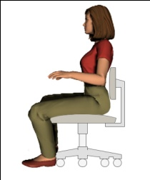  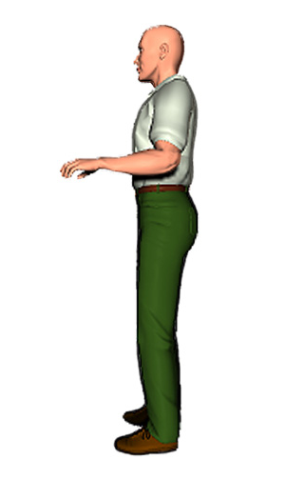  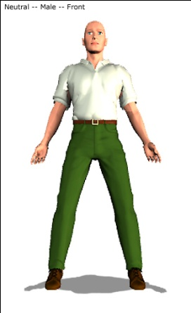

Static Posture
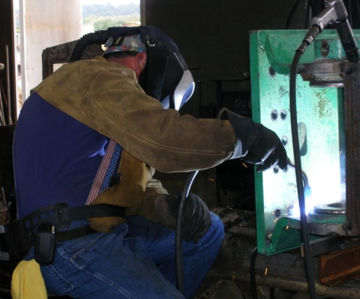
The optimal design of work results in tasks that involve slow to moderately paced movements and varied patterns of movement. Little or no movement at a body part elevates the risk of discomfort and MSDs because the flow of blood through muscles to provide energy and remove waste depends on movement. Tasks that involve static postures quickly lead to discomfort, especially if combined with exposure to other risk factors.

Repetition
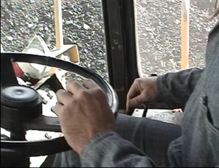
If the task involves repetitively performing similar patterns of movement, and especially if the cycle time of the repeated movement is short, then the same tissues are being loaded in the same way with little opportunity for recovery. Such repetitive tasks are likely to pose a high risk of cumulative injury, especially if combined with moderate to high forces (or speeds), awkward postures, and/or long durations.

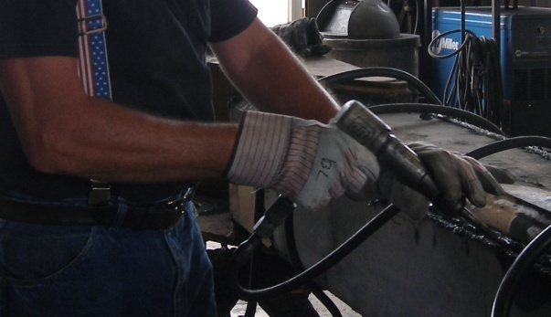
Vibration
Exposure to vibration in manual tasks comprises two distinct types: hand-arm vibration (typically associated with power tools) and whole-body vibration (typically associated with vehicles). In both cases, the vibration exposure impacts MSD risk both directly and indirectly.
Exposure of the upper limbs, and particularly the hands, to high-frequency vibration associated with power tools is a direct cause of damage to nerves and blood vessels. Short-term effects are temporary loss of sensation and control, and blanching of the fingers (vibration white finger syndrome). These effects may become irreversible with long-term exposure and lead to gangrene and loss of the affected fingers [NIOSH 1989]. Use of vibrating power tools is also an indirect cause of MSD risk to the upper limbs because the vibration increases the force required by the upper limbs to perform the task. The degree of risk increases with higher-amplitude vibration tools (hammer drills or jackhammers).
Similarly, long-term exposure to whole-body vibration (typically from vehicles) is associated with back pain [Bovenzi and Hulshof 1999; Lings and Leboeuf- Y de 2000; ACGIH 2007a]. As well as a direct effect on the back, exposure to whole-body vibration also has an indirect influence on MSD risk by causing fatigue of the back muscles. Again, the risk is greater when the amplitude of vibration is high (heavy vehicles and/or rough terrain).

Another important consideration is the duration of the exposure. If a task is performed continuously, without a break and for a long time, the tissues involved do not have opportunity for recovery, and the risk for a cumulative injury increases. Performing several tasks during a shift can provide recovery if the tasks involve different body parts and movement patterns.
In general, a root cause is defined as a source of a problem. In terms of MSD risk factor exposures, it is important to determine why the exposure is occurring or to identify the root cause of the exposure. Root causes modify the degree of risk in two ways. Some root causes are characteristics of the work that commonly lead to increased exposure to the risk factors discussed previously. Modification of these root causes will likely reduce the MSD risk. Other root causes have an indirect influence on manual task MSD risk. Understanding the root causes of risk factor exposures can help determine the most effective means for reducing or eliminating the exposures. Examples of root causes include the following:

Workplace or Work Station Layout

- Working in confined spaces is likely to result in the necessity to adopt awkward postures to perform tasks.
- Work stations with restricted visibility typically result in awkward and static postures, especially of the neck.
- Work stations with inappropriate location of visual displays (usually too high or located to one side) cause awkward postures, especially of the neck.
- Standing work leads to fatigue if undertaken for long durations.
- Kneeling work causes high force on the knees.
- Working below the height of the feet inevitably leads to extreme trunk postures.
- Working overhead requires awkward and static postures of the shoulders.
- Work stations that require reaching to handle objects create awkward postures.
- Work surfaces that are too high or too low lead to awkward postures.
- Locating objects to be handled below knee height results in trunk flexion.
- Locating objects to be handled above shoulder height leads to working with the elbows above the shoulders.
- Carrying loads for long distances results in fatigue.

Objects, Equipment, and Tools
- Any unpredictability, such as handling an object with uneven or shifting distribution of its mass, may lead to overexertion of muscles.
- Handling heavy loads, even if they are not lifted, may require high force because of the inertia of the load.
- Handling large loads, even if they are not heavy, may require high forces because of the distance of the center of the load from the body.
- Objects that are hot, cold, or otherwise noxious may lead to the load being held away from the body, which increases stress on the lower back and shoulders.
- Objects with handles may result in contact stress or decreased control of the object.
- Poorly maintained tools (i.e., dull bits or blades) may increase the force required.
- Using tools not appropriate to the task (too powerful or not powerful enough, too heavy, incorrect handle orientation, etc.) may lead to awkward postures and forceful exertions.
- Handling loads with one hand results in only one side of the body supporting the load, which could lead to overexertion.
- Triggers that require sustained force or are operated with a single finger may lead to fatigue and overexertion.
- Gloves generally increase the force requirements of a task.

Environmental Conditions
- Low lighting levels or glare may cause awkward postures or prolonged squinting of the eyes.
- Exposure to hot environments increases fatigue, especially for heavy work.
- Exposure to cold, in addition to other risk factors, is implicated in the development of vibration white finger syndrome or hand-arm vibration syndrome, and carpal tunnel syndrome from increased hand forces generated as a result of wearing gloves and cold hands.

- Uneven or poorly maintained surfaces can increase forces required to push/pull carts, the amplitude of whole-body vibration, or the likelihood of slips and falls.

Work Organization and Systems
Certain factors of work organization and systems may lead to fatigue and overexertion of muscle groups. In some cases, recovery times do not permit the worker to return to baseline values prior to returning to work. Examples of such factors include:
- High work rates
- Lack of task variety
- Uneven temporal distribution of work causing high peak loads
- Understaffing
- Irregular or long shifts
- Pay schemes that encourage working faster or longer

Studies have shown that even when controlling for higher workloads, elevated rates of discomfort and/or MSDs still occurred because of the presence of other work organization and system factors not typically associated with discomfort or MSDs [Bernard 1997]. The physiological mechanism for this effect is not well understood. Addressing these factors in addition to implementing controls that reduce risk from higher workloads may increase success at reducing rates of discomfort or MSDs. These factors may include:
- Job dissatisfaction
- Perception of intensified workload
- Lack of job control
- Uncertainty about job expectations
- Lack of opportunity for communication and personal contact
- Cognitive overload, monotonous work, frequent deadlines, interpersonal conflict

Element 3: Controlling MSD Risks During Manual Tasks

There are several ways to reduce MSD risks that occur during the performance of manual tasks. From an ergonomics perspective, the emphasis is first on eliminating or reducing risk through design controls; secondly on administrative controls, such as job rotation or enlargement; and then on personal protective equipment (PPE). When risks cannot be eliminated with design controls, administrative controls and PPE may also be required to manage the residual risks. Regardless of which controls are chosen, training is an important aspect of the implementation to ensure that workers are aware of the appropriate way of performing work and using equipment.

Elimination
Having determined that manual tasks with risk factor exposures are performed in a workplace, the next step is to determine whether any or all of the manual tasks can be eliminated. If this is possible, it is the most effective way of reducing MSDs. Some manual tasks can be eliminated by examining the flow of materials and reducing double handling. Others may be eliminated by changing to bulk-handling systems. Outsourcing manual tasks may also be considered as a way of eliminating exposures to your workers if the organization undertaking the task has specialized equipment that reduces the risk for its workers to acceptable levels. It would not be appropriate to out source manual tasks if the risk was not reduced. Some tasks, such as cleaning up waste, are nonproductive and may be eliminated or reduced by examining the source of the waste.

Design Controls
If, after the possibilities have been examined, it is determined that some hazardous manual tasks cannot practicably be eliminated, and the risks associated with these tasks have been assessed, the next step is to devise design controls that will reduce the MSD risks. This step is most effectively undertaken in consultation with all workers who will be affected by the change, including maintenance as well as operational staff. Apart from the fact that workers are the ones who know most about the tasks, the probability of success of the design changes is enhanced if the workers concerned have a

sense of ownership of the changes. Before implementing the design controls, it is also important to consider whether new hazards will be introduced as a consequence of the control.
Considering the following aspects of the work area and task is a useful way of thinking about possible design controls:

Work Areas: Work Height, Space, Reach Distances, Work Flow, Adjustability
The design of work areas has a large impact on MSD risks. For example, limited space, limited clearances, and restricted access to work are common causes of awkward postures. Work should be located at an appropriate height and close to the body. Providing adjustability of work stations may be an option to accommodate workers of different sizes. Workplaces should be designed to increase postural variability during work.

Loads: Size, Shape, Weight, Stability, Location, Height
The nature of loads that are delivered to a workplace, handled within a workplace, or produced by a workplace are a common source of risk factor exposures when performing manual tasks. Increasing the size and mass of loads and implementing mechanized bulk-handling systems are effective design controls. Reducing the size and weight of loads is another option, but may require training and ongoing supervision to ensure that multiple loads are not handled simultaneously to increase speed. Ensuring loads are easily gripped by providing or incorporating handles is important. Hot or cold loads should be insulated, or proper protective clothing should be provided to allow the loads to be comfortably held close to the body. Where loads are manually handled, they should be stored at waist height rather than on the floor or above shoulder height.

Tools: Size, Weight, Handles, Grips, Trigger, Vibration
Poorly designed handtools are a common source of awkward postures, high exertion (particularly of the small muscles of the hand and arm), and hand-

arm vibration. Handtools should be designed such that joint postures remain close to neutral during use and should be as light as possible. Heavy tools may be supported by a counterbalance to reduce exertion. While power tools reduce exertion, the vibration associated with power tools introduces a new risk, and tools and consumables should be chosen to minimize the amplitude of the vibration as far as possible. Tools also need to be maintained (e.g., keep blades and bits sharp) to minimize vibration levels.

Mechanical Aids: Hoists, Overhead Cranes, Vacuum Lifters, Trolleys, Conveyers, Turntables, Monorails, Adjustable Height Pallets, Forklifts, Pallet Movers
A large number of different mechanical aids are available to reduce risk factor exposures, and these can be effective controls. However, care is required to ensure that the use of the aid does not significantly increase work performance time. If it does, the likelihood that the control will be effective is reduced because administrative controls and ongoing supervision will be required to ensure use. Introducing mechanical equipment, such as forklifts, also introduces new risks that require control. For example, using forklifts requires that traffic patterns be established and visual obstructions be eliminated.
The design of mechanical aids requires careful consideration. For example, cart wheels should be as large as possible to reduce resistance (getting stuck in cracks), and vertical handles should be provided that allow the cart to be gripped at different heights by different sized workers. Where mechanical aids are introduced to control manual tasks risks, it is important to ensure that they are maintained in working order and are available when and where required.
Further information on mechanical aids can be found in Ergonomic Guidelines for Manual Material Handling [NIOSH et al. 2007].

Administrative Controls
For situations where there are no effective design controls or the design controls that are implemented do not fully address the exposures, it may also be necessary to consider additional administrative controls. Administrative controls rely on human behavior and supervision and, on their own, are not an effective way of controlling manual task MSD risk. Administrative controls include the following:

Maintenance
Maintenance of tools, equipment, and mechanical aids is crucial, but requires a schedule to be developed and supervision to ensure that it occurs. Following a regular schedule of preventive maintenance not only impacts productivity, but can also reduce exposures to risk factors. For example, preventive maintenance for mobile equipment can avoid major repair tasks that usually involve exposures to several risk factors, such as excessive force, awkward postures, and vibration. Another aspect of maintenance is good housekeeping.

Workload
MSD risk associated with manual tasks may be reduced by reducing shift duration or the pace of work. It may be possible to change the distribution of work across the workday or week to avoid high peak workloads. Ensuring that appropriate staffing levels are maintained is important. Provision of adequate rest breaks can reduce MSD risks.

Job Rotation and Task Variety
It may be possible to reduce MSD risks by rotating staff between different tasks to increase task variety. This requires that the tasks are sufficiently different to ensure that different body parts are loaded in different ways. Alternatively, multiple tasks might be combined to increase task variety.

Team Lifting
Team lifting may be effective in reducing injury risk where the load is bulky, but relatively light. However, if the load is not "heavy enough," an employee may try to handle the load individually, especially if there are not many other employees in the area. If team lifting is used as a control, training and supervision are required to ensure that the task is only done when appropriate staff are available to perform the task.

Personal Protective Equipment
Some forms of PPE may be effective in reducing risk factor exposures. However, PPE only serves as a barrier, and the protection provided depends on the effectiveness of the barrier. Consequently, PPE should only be used when risk factor exposures cannot be eliminated or effectively reduced with design controls, or design controls are not economically feasible. PPE may also be considered as an interim control when design controls cannot be implemented in a timely manner. Kneepads, protective aprons, cooling garments, and antivibration gloves are examples of PPE.

Element 4: Monitor and Review
Managing manual task risk is an iterative "continuous improvement" process. Following implementation of any control measure, it is important to check that the controls are working as anticipated and that new risks have not been introduced. It is important to evaluate the effects on not just the workers directly involved with the change, but also other workers and processes that may be affected. Although this element is critical to successful processes, it is sometimes ignored or forgotten as the next issue or problem that arises usually needs the same resources to resolve.

Element 5: Record-Keeping
Keeping records of the steps taken in the risk management process is important for several reasons. It will ensure that an effective risk management process is in place by documenting the changes in risk factor exposures and MSD incident/severity rates. It provides a way of tracking the improvements made, maintaining the corporate memory of the reasons that changes were made, and allows for justification of future changes. Documenting controls or task

improvements also allows this information to be shared so that similar tasks at other sites may also be improved using the same or similar controls.

Participatory Ergonomics

"Participative ergonomics" is based on an underlying assumption that the workers involved are the "experts" and must be involved at each stage of the risk management process if it is to be successful. In an MSD management context, employees and management participate jointly in hazard identification, risk assessment, risk control, and evaluation of the risk management process.
Many variations in the models and techniques used in participative ergonomics have been developed [Haines and Wilson 1998; Haims and Carayon 1998; Laing et al., 2005; BurgessLimerick et al. 2007]. However, a common element is to ensure the use of expert knowledge that workers have of their own tasks by involving the workers in improving their workplaces. Management commitment and provision of resources including a champion to promote the process, workers' and management understanding of relevant ergonomics concepts and techniques, and a process to efficiently develop and implement suggested controls are also important components of successful participative ergonomics interventions.
Using participative ergonomics to address MSDs associated with manual tasks usually entails an ergonomics team, which includes workers as team members. This team must be knowledgeable about the risk management process, have the skills and tools required to assess manual task risks, understand the risk control hierarchy, and have knowledge of general principles of control strategies for eliminating and controlling manual task risks. Implementing an effective ergonomics risk management process also requires that all employees be able to identify risk factor exposures associated with manual tasks and be aware of the aspects of manual tasks that increase MSD risks. Having this awareness allows employees to consider ways to improve their jobs and ultimately reduce risk factor exposures. Training in risk assessment and control strategies ensures successful participation of workers in an ergonomics risk management process. Training team members to acquire these skills and work within a risk management process is a key concern. Team members identify risk factor exposures associated with their work and follow a risk assessment process that develops control suggestions. The team members

plan the implementation of key controls and are subsequently shown how to evaluate those controls. Management commitment and effective risk management systems are required in order for the approach to be effective. Access to external ergonomics expert assistance may be necessary for particularly difficult or complex problems. It is also important to note that ergonomics is equally concerned with improving productivity and reducing waste, as well as reducing injury risks [Dul 2003]. This is crucial because any work modification that is implemented to reduce MSD risk should be easier, quicker, or more efficient than the previous methods of work. If not, the chance of acceptance and adherence to the new methods is markedly reduced, and ongoing supervision will be required to ensure compliance.

Evolution of Risk Management Processes

A risk management model, originally developed by Westrum [1991] and Westrum and Adamski [1999] and later broadened by Hudson [2003], describes the evolution of risk management strategies and the progression as a company moves from a pathological to a generative stage with regard to how risk is managed (Figure 1). At one end of the spectrum, the pathological stage can be thought of as the stage in which safety problems are attributable to the workers. The main driving force is the business and not getting caught by regulators. The reactive stage is the point where companies consider safety seriously, but only intervene following the occurrence of accidents. At the calculative stage, safety is driven by management systems; it is still imposed by management and not sought by the workforce. In the proactive stage, the workforce is becoming increasingly active in risk management. Finally, in a generative stage, everyone is involved in risk management and tries to maintain the well-being of themselves as well as their coworkers.

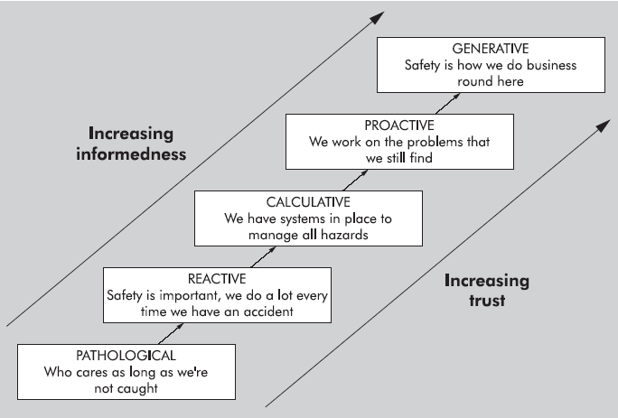
Figure 1. Evolution of health, safety, and environment risk management process
[Hudson 2003].

This risk management hierarchy may be applied to an ergonomics risk management process where the company and the workforce integrate ergonomics principles into their risk management process. In this case, the approach follows the same path but with a focus on eliminating MSDs.

Pathological Stage: Workers and companies are unaware of how MSDs occur and let workers look out for themselves. Employees may have the signs and symptoms of an impending MSD, but no changes are made to the workplace. No formal job safety analysis techniques are used, and productivity is the primary focus.

Reactive Stage: Analysis of the incident is after the report of an MSD or several MSDs, and the solution or correction is often individualistic. Others doing similar jobs may or may not be considered as it is thought to be one particular employee's problem. For MSD-related issues, often the workers believe that aches and pains are just part of their jobs or the aging process. They do not know that these recurring aches and pains are precursors to cumulative injuries and that these injuries can be prevented through planning of jobs, work environment, and equipment purchasing.

Calculative Stage: At this stage, companies may accuse workers of being "hurt at home" or by "their hobbies" rather than by their work environment or by poor work task design or planning. Some management may use some outside training for proper lifting techniques or purchase "ergonomically designed" PPE or equipment to resolve issues. In some cases, the company may fix very specific problems successfully through training and procedural approaches. These interventions have a positive impact on the situation, but the more global philosophy of prevention is not adopted. In addition, there is no formal followup to see if the problem was resolved or if any other problems have resulted. In this stage, management may be aware of the cumulative injury process, but employees are not. Safety is still in the hands of management and not pushed down to the employee level. Management believes that the system in place works well to address issues brought to their attention.

Proactive Stage: Employees are educated about ergonomics principles, cumulative injury progression, and techniques to identify and reduce risk factors associated with MSDs. Management relies on employees to bring issues to them and to resolve them together. Management may also seek to provide periodic observations of all tasks or establish a wellness or fit-for-duty program. Ergonomic principles are used when evaluating and redesigning jobs. Management and workers are not waiting for MSDs to occur, but rather are looking for exposures to indicators (risk factors) that point to a potential MSD and then reduce or eliminate that exposure. In some cases, a consultant in ergonomics may be hired or an ergonomics committee formed. Focusing on risk factor exposures and reports of MSDs investigates why (root causes) such situations are occurring instead of what or when. The company takes responsibility for employees' health during and outside of work and places less blame on the employee. Job safety analysis techniques include the evaluation of risk factors at each step in the standard operating procedures to ensure that they are considered. Finally, a procedure is put in place to conduct followup that ensures the solutions worked and to investigate other emerging issues. Anecdotally, workers appreciate these analyses and believe it is in their own interest and not just the company's interest. Most solutions are off-the-shelf, and lessons learned are communicated throughout the mine and even company-wide. Still, the

value (cost/benefit) of these interventions may not be fully understood and consequently may be underreported.

Generative Stage: There is anticipation of issues with regard to old and new processes and equipment. The ergonomic principles are integrated into the designing and planning processes. This integration occurs in the beginning and is understood to be as important as other engineering and purchasing decisions. Employees are trusted to make decisions about their jobs and recognize situations where changes need to be made. At this point, the employees are empowered with resources to make changes and inform management of needs. Investigation of risk factors, signs, and symptoms of MSDs is driven by an understanding of their root causes. The solutions are cost-effective and creative, and followups are done automatically. A database of all reported issues and changes to the workplace and equipment is available to the entire company and serves as an informational base from which to make the best purchasing and planning decisions. Safety is in the hands of educated employees. The cost of MSDs or cumulative injuries is reduced and profits are increased, the workforce returns home healthy, operating procedures include ergonomic principles, better habits are passed on to new recruits, and management and employees together see the overall interaction of systems and people. Less time is spent on addressing health and safety issues because they are under control and are the responsibility of all parties.

There are many characteristics of these stages not addressed here. However, the above is a summary of what a company might expect as it moves toward a more generative risk management approach. A company can use these descriptions to measure where they are and how to get to where they want to be [Shell International 2003]. The first step to achieving generative status is to understand what information is needed and how to educate employees to help themselves and their coworkers.

