ERGONOMICS OBSERVATIONS

Mine:_____________ Location:________ Team:________________ Task:________________________

Time:____________ Date:___________ # Observed:_________ Observer:________________________

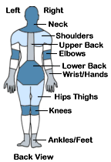
- Check all the risk factors that you observe.
□ forceful exertion □ repetition □ static posture □ awkward postures □ contact stress
□ pressure points □ vibration □ other__________________________

- How often is this task performed? ________times/shift ________shifts/week
□ Seasonal ___weeks/year ________shifts/month ________shifts/year

- Does employee experience any discomfort when doing this task? Yes No
If yes, what body parts have discomfort? (Place X on body part)

- What is causing the risk factors? Check root cause (s) and give brief description.

CHECK | ROOT CAUSE | BRIEF DESCRIPTION
 | Effort or Strength Required
 | Location of Parts, Equipment or Tools
 | Position of Parts, Equipment or Tools (How the part is positioned in reference to the worker)
 | Design of Parts, Equipment or Tools
 | Frequency of Task (How often is task done)
 | Duration of Task (How long it takes to do task)
 | Productivity Levels
 | Method Used / Required to do the Task
 | Training Not Adequate / Need Training
 | PPE Not Available / Wrong PPE Used
 | Environment – Heat, Cold, Restricted Space, etc.
 | Other

5. Rate the degree of risk factor exposures for the observed task: None Low Medium High Very High

COMPLETE ONLY IF EXPOSURES ARE RATED MEDIUM, HIGH or VERY HIGH

6. Is there another way to do this task that eliminates/reduces the risk factor(s)? Yes No
If yes, describe how the task can be changed: __________________________________________________

7. Was the risk factor exposure resolved at the time of the observation? Yes No

8. Comments: _____________________________________________________________________________

9. Indicate options discussed by checking the box next to the solutions shown below and back side of page.
Personal Protective Equipment  - Anti-vibration gloves – reduce vibration transmission  - Knee pads – reduce pressure points  - Shoe inserts – reduce foot discomfort and fatigue  - Cooling devices – reduce body temperature increases  - Cold weather clothing |  | Administrative Controls  - Job enlargement  - Job rotation  - Work pace and duration  - Work-rest cycles  - Training  - Shift schedule / overtime  - Exercise / stretches
MMH (Lifting) – Think Smart  - Plan activity  - Keep loads close to body  - Use lifting assist  - Ask for assistance  Balance load/Stronger person on bottom/Talk  - One-handed lift / carry  Avoid/Use other hand as counterbalance/Alternate Hands  - Avoid bending at the waist to lift objects  - Avoid twisting – take a step and turn | MMH (Push/Pull) – Think Smart  - Use push instead of pull  - Keep elbows near 90º  - Provide clear path  - Avoid slopes  - Avoid uneven floors | MMH Design Strategies  - Avoid manual handling  - Use mechanical aids (hand trucks/carts)  - Use carts with large casters  - Modify workplace  Store heavy items between knees & shoulders –Avoid placing on floor  Store light items on top shelf  - Decrease object/container size  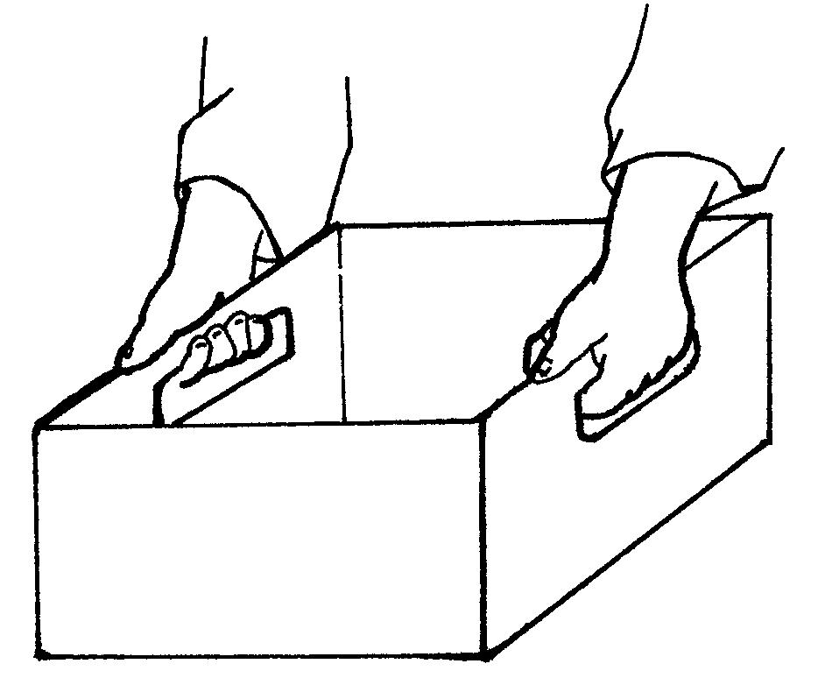  - Decrease object/container weight  - Change container shape  - Add handles
Reducing Forceful Exertions  Use  - Power tools  - Fixtures  - Slides & rollers  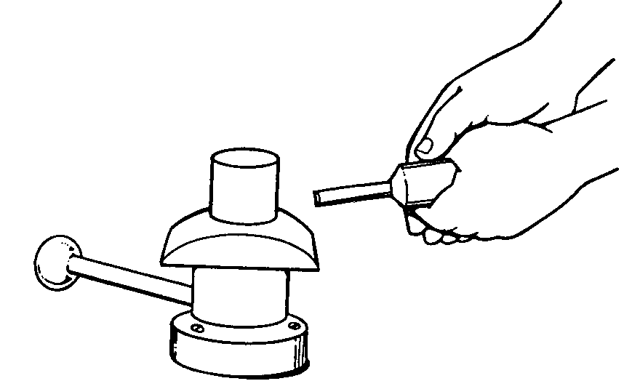  - Mechanical aids  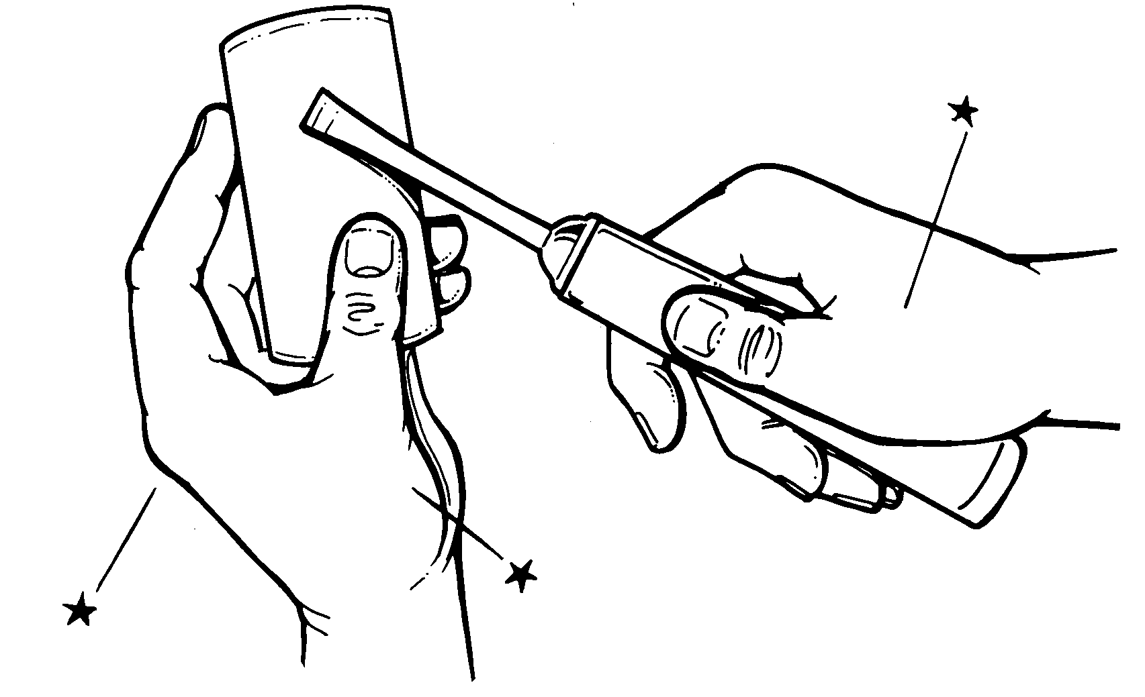  - Gravity to move materials  - Leverage  - Power grip – not pinch grip | Reducing Excessive Motions  - Use power tools  - Eliminate double handling  - Use efficient motions  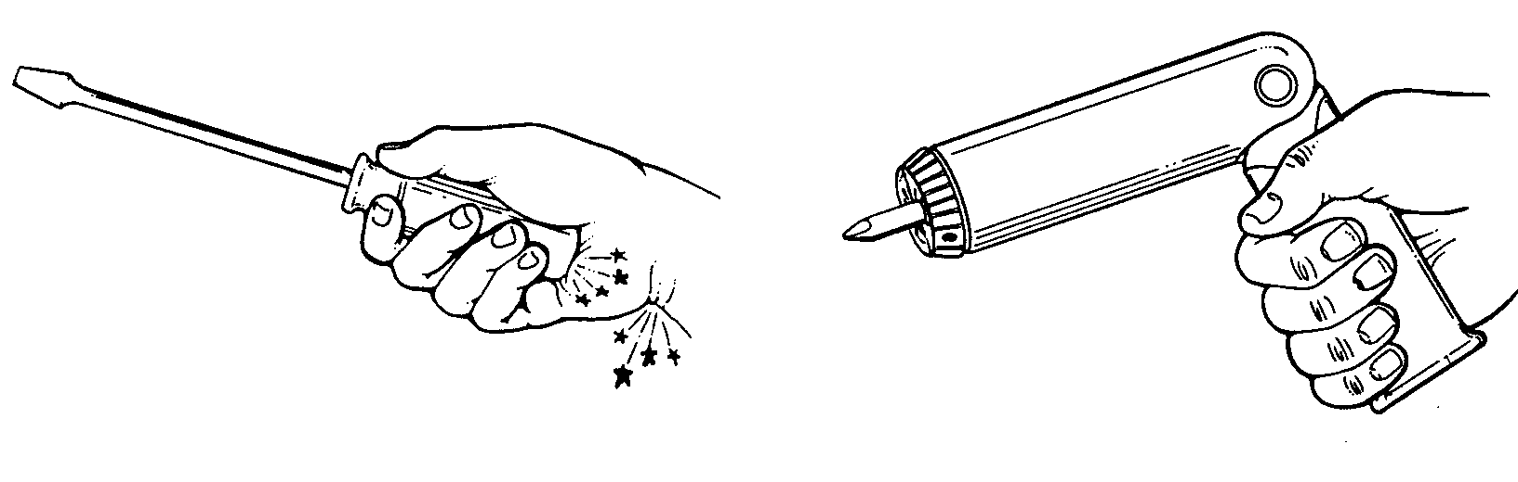 | Reducing Fatigue  - Use arm rests and other types of supports  - Use fixtures  - Add straps, handles, handholds  - Use power tools (light-weight)  - Reduce carry distances  - Reduce pushes / pulls  - Use floor mats
Reducing Awkward Postures  - Adjust workstation and chairs  - Keep items within easy reach  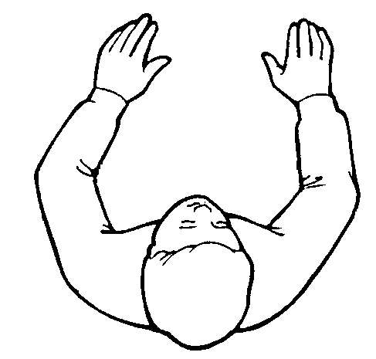  - Remove barriers  - Work at elbow height  - Use bent handle tools | Good Standing Posture  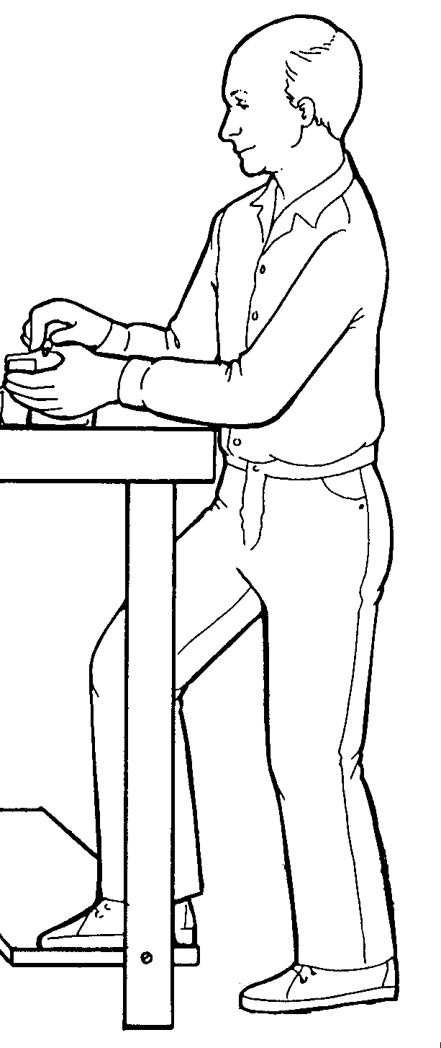  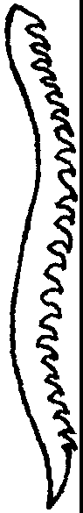  - Neck straight  - Shoulders relaxed  - Elbows at side  - Keep wrists in same plane as forearm  - Keep elbows below the shoulders  - Maintain the S-curve of the back | Good Sitting Posture  - Operate controls without reaching, bending, or twisting your wrists or body  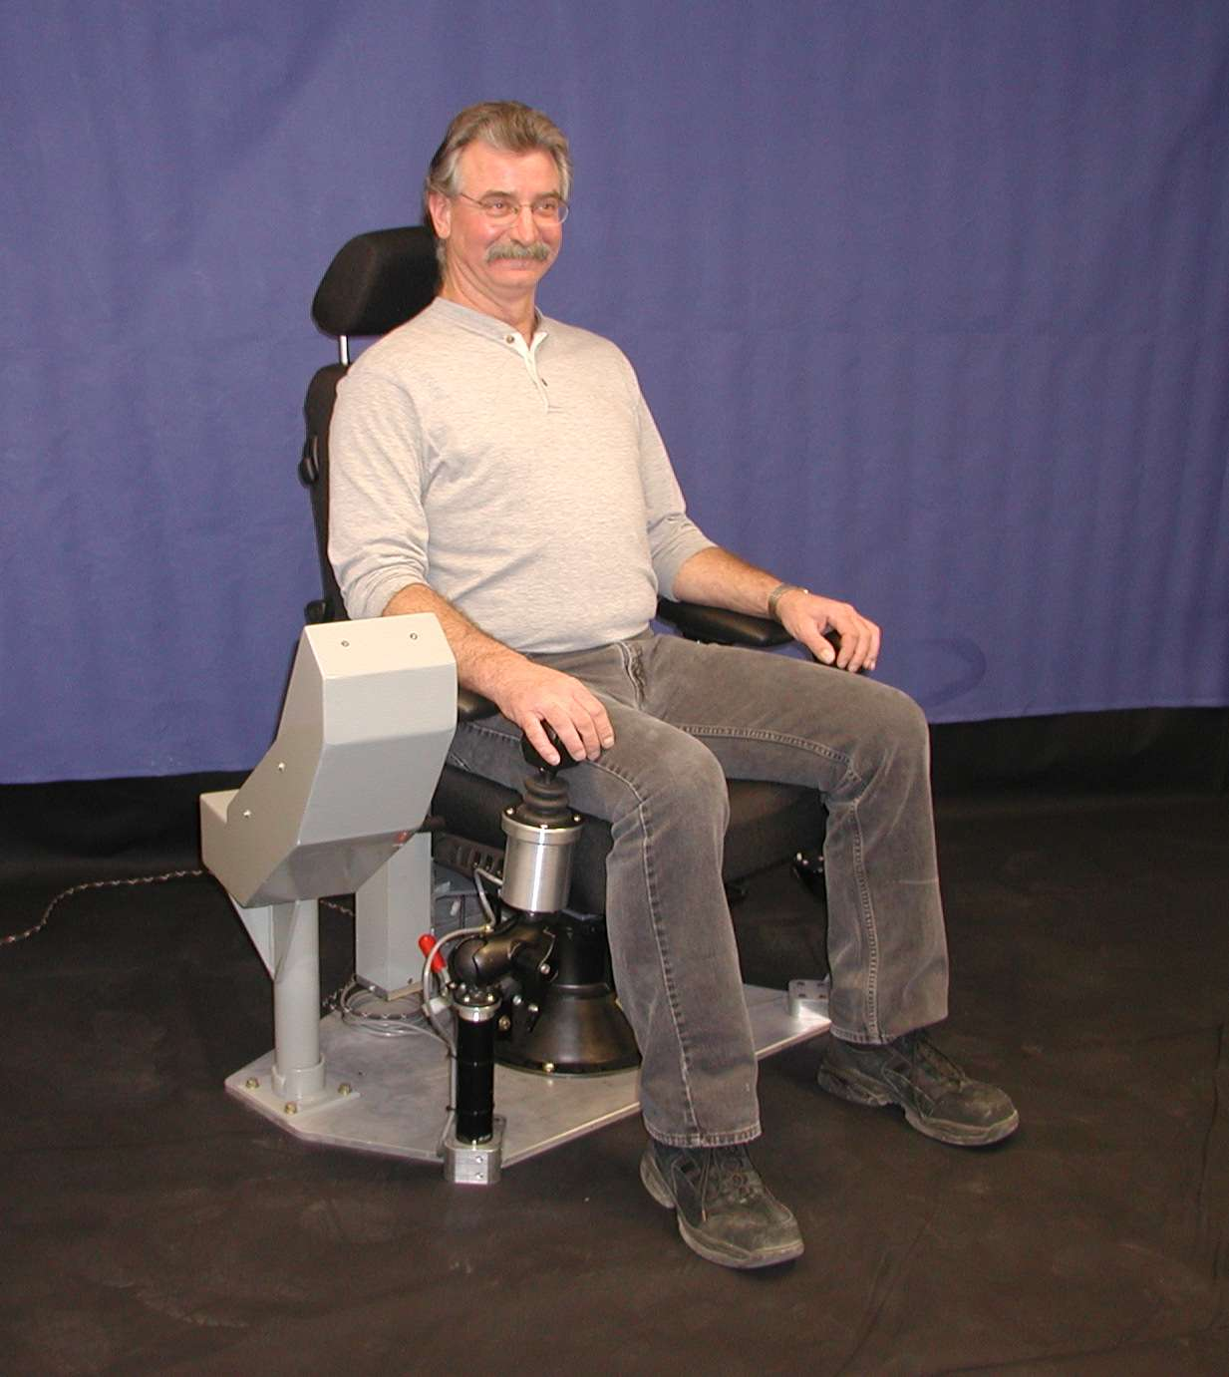  - Seat back - 90° to 125°  - 2” clearance between knees and front of seat cushion  - Seat height 2 inches below knees when standing  - Relax shoulders and upper arms - position perpendicular to floor  - Keep arms and elbows close to body  - Position thighs parallel to the floor  - Position lower legs perpendicular to floor  - Rest feet firmly on floor or use footrest
Minimize Pressure Points/Contact Sress  - Use tools with curved handles that follow contour of hand  - Use tools with rounded handles – no finger grooves  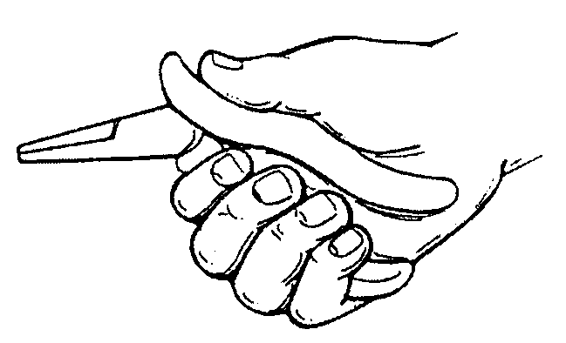  - Add padding to sharp edges | Improving Work Environment  - Provide good, adjustable lighting  - Provide task lighting  - Place workstations perpendicular to windows  - Provide temperature controls  - Provide air conditioned break areas  - Provide humidity controls

