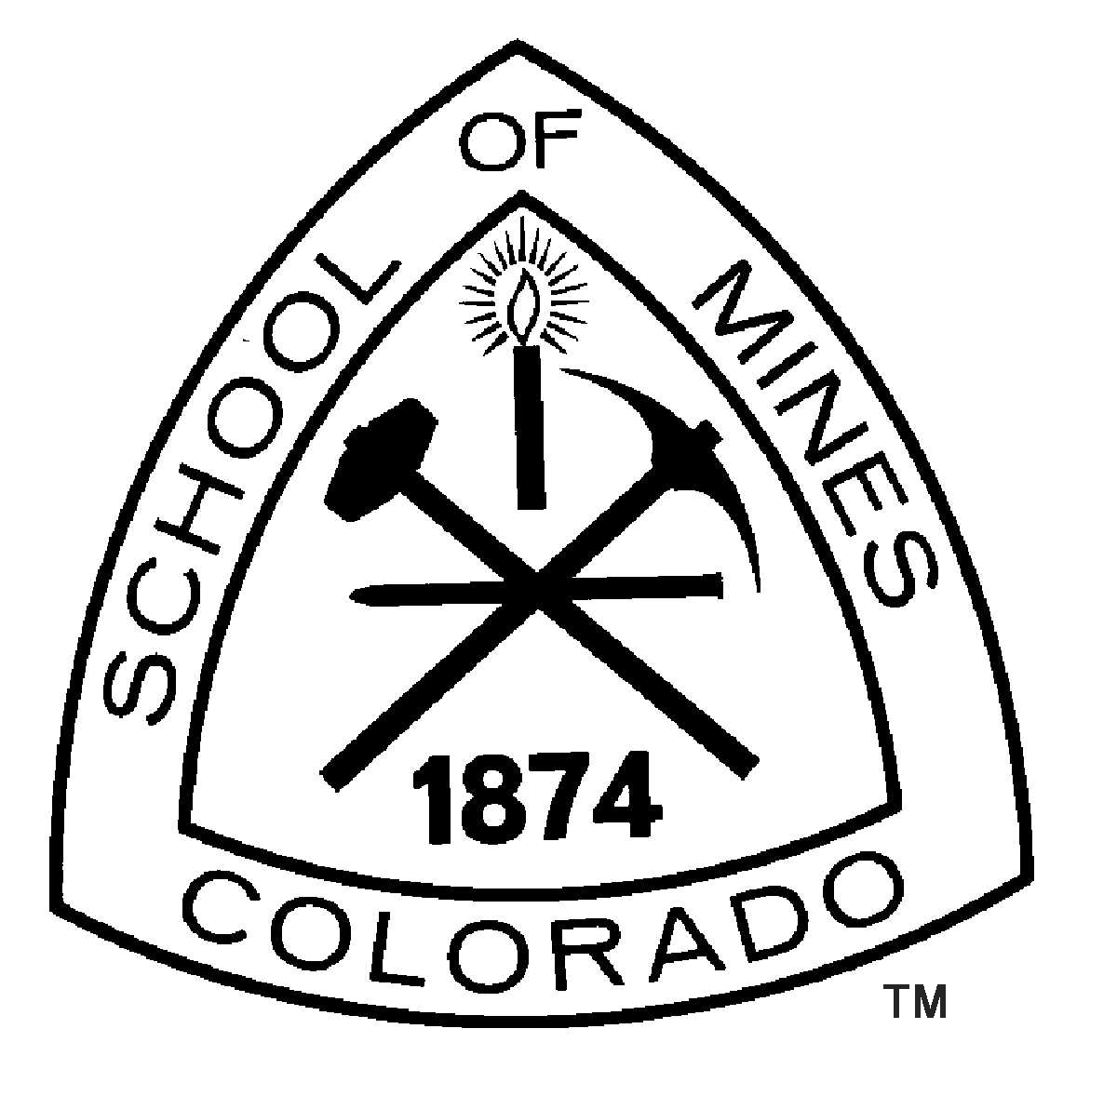 | Colorado School of Mines  Recreational Sports  Outdoor Recreation Center Intern

Location: The Outdoor Recreation Center (ORC) at Colorado School of Mines located in Golden, Colorado. Golden is located in the Front Range of the Rocky Mountains and is just a short drive from Denver and Boulder. Golden is home to a kayak course, multiple rock and ice climbing locations, and abundant hiking and biking trails that are within walking/biking distance of campus. With more than 300 days of sunshine a year Golden is an ideal location to program year-round outdoor recreation activities.

Program Description: The purpose of the Outdoor Recreation Center is to provide outdoor recreational opportunities and resources for the members of the Colorado School of Mines community. The Outdoor Recreation Center facilitates trips and events that include: hiking, camping, biking, caving, skiing/snowboarding, rock and ice climbing, canyoneering, mountaineering, snowshoeing, avalanche training, whitewater boating, and much more. The Outdoor Recreation Center is located in a state of the art facility that opened in 2007. The facility includes a 4,000 sq. ft. climbing wall, a nine ft. tall free standing outside boulder, a trip planning room, a resource room, a bike and ski shop as well as rental and storage facilities.

General Description: The Outdoor Recreation Center Intern will assist the Director in managing the daily operations of a collegiate outdoor recreation facility. The intern will also aid in overall administrative duties for the Student Recreational Center such as trainings, workshops, and accountability of all student staff.

Specific Job Responsibilities: Assist with planning and developing programs and policies, organizing activities, and administrating all aspects of the Outdoor Recreation Center (ORC) including special events. Additional responsibilities will include: assisting with the supervision and development of the Student Managers of the rental program, the bike/ski shop, the climbing wall, and the trip leader manager. Supervise and develop rental, wall, trip leader, and bike/ski student staff. Additional contributions will include: assisting with the implementation of a creative marketing plan, budget analysis, and management of all expenditures and generation of revenue for all ORC programs; recruiting, hiring, training, supervising, scheduling and evaluating student staff; developing, executing and evaluating day, weekend, weeklong and extended trips. The intern will also instruct a number of short classes and workshops on a variety of topics. The ORC Intern will oversee the management of the climbing wall as well as the trips programs.

Qualifications: Previous outdoor recreation experience is required. Applicants should be a competent backcountry traveler in all seasons. Experience leading groups in the backcountry is required. Applicants must be dedicated, motivated, self-directed individuals with a strong work ethic and outstanding leadership skills. Applicants must demonstrate good judgment and decision-making abilities. Applicants must possess a positive attitude, well developed teaching abilities, exceptional customer service skills and superior communication skills. Applicants must have a valid driver’s license and medical insurance throughout the duration of employment.

Preference will be given to applicants who possess the following experience or certifications:
- Experience with other institutions or colleges (NOLS, Outward Bound, American Alpine Institution, Wilderness Education Association etc.)
- Experience with bike and/or ski maintenance
- Wilderness First Responder (WFR,) or EMT/WEMT
- Current CPR
- Completion of an Avalanche Level One course, AMGA course or other applicable certification
- Previous experience working with a collegiate Outdoor Program

Note: Applicants who do not currently hold one or more of these certifications must be willing to acquire them in a timely fashion after hire at some cost to the applicant.

Education: Completion of college level educational training in subjects related to outdoor recreation or administration is required. A Bachelor/Master’s degree in Outdoor Recreation or a related field is highly desirable.

Dates of Employment: August 1st, 2012 – August 2013. Start date could be earlier. It’s possible for this position to be extended to a second year.

Work Hours: 40 hrs. /week

Pay Level: Stipend of $14,500 for the year.

Benefits: The Outdoor Recreation Center offers numerous opportunities for leadership training, personal/professional development, and recreational activities. The ORC also offers staff discounts on the purchase of equipment and outdoor clothing as well as the possibility for a complementary Ski Pass. ORC staff members are able to use all of the center’s resources including rental equipment, attend ORC trips workshops and events at no cost (some exceptions). Furthermore, some funds may be available to supplement the cost of obtaining certifications, trainings. On campus housing is available at a reduced rate. Finally, the ORC Intern will receive a free year’s membership to the Student Recreation Center.

Contact: For more information, please contact Rob Thompson, Director of the Outdoor Recreation Center at Office: 303-273-3907, Cell: 720-272-2875, rbthomps@mines.edu. To learn more about the ORC check out the website at http://recsports.mines.edu/REC-Outdoor-Recreation.

To Apply: Interested individuals should submit a cover letter addressing each of the qualifications, resume, experience log and the names and contact information of three professional references to:

Rob Thompson
Director of the Outdoor Recreation Center
Colorado School of Mines
1500 Illinois St.
Golden, CO 80401
rbthomps@mines.edu (preferred)

A review of applicants will begin July 2nd of 2012.

CSM is an EEO/AA employer and is committed to enhancing the diversity of its campus community. Women, minorities, veterans, and individuals with disabilities are encouraged to apply.

Employment with CSM is contingent upon the satisfactory completion of a background investigation.

