### Colorado School of Mines

### Outdoor Recreation Center in Coordination with Residence Life presents:

### W.I.L.D.

### Wilderness Instruction and Leadership Development

### ORC%20logo%20with%20correct%20font%20for%20WILD.jpg

### Expedition:

### Backpacking and Mountain Summit

### Colorado Trail, Leadville, Colorado

Welcome to W.I.L.D.!

Get your hiking boots ready because you are about to venture out with the Colorado School of Mines Outdoor Recreation Center on an exciting W.I.L.D. expedition. The W.I.L.D. program in which you are participating is designed to introduce you to other incoming students from your residential floor. An Outdoor Recreation Center (ORC) professional staff member, ORC trained trip leaders, and your Resident Assistant will also be joining you for an experience of a lifetime. We all look forward to spending this exciting expedition with you!

This document is designed to inform you about the experience and answer any questions or concerns you may have about your expedition. Please read through all of the materials and if you have further questions contact Rob Thompson, the Director of Outdoor Recreation at 303-273-3907.

I look forward to meeting you on our exciting adventure this summer!

Sincerely,

Rob Thompson

Director of the Outdoor Recreation Center

**Table of Contents**

Purpose of W.I.L.D. …………….. 3

Destination Information ………….. 3

Expedition Preparation ……………4

Expedition Itinerary ……………….4

Equipment List ……………………5

Directions to Mines ………………..7

Additional Information ……………8

**Purpose of W.I.L.D.**

The goal of the W.I.L.D. program is to aid residence of the outdoor recreation themed housing floor as you transitioning into the Colorado School of Mines community. The first year at college is the most critical and often challenging in the students mind. Many students leave school or drop out completely because of the challenges they face. College can be tough because of the first time freedom students have making decisions, meeting new people, fitting into a new community, and adapting to a new culture. Our goal is to help with these issues by working to build a support network for you. We want to provide you with resources to help if you struggle, and provide a personal confidence building and challenging experience in the outdoors before the challenges and rigors of the school year begin. We hope this experience will aid you in making smart decisions if necessary, during your first year. W.I.L.D. will be your first step toward a successful Mines experience and ultimately graduation.

The Colorado School of Mines is known for providing its students with a world class education. What might not be as obvious is we at CSM try to help students succeed both inside and outside of the classroom. Today’s graduates will leave CSM not only with a tremendous technical background but also strong leadership skills, communication skills and they ability to problem solve whether in the backcountry, the boardroom or the lab.

**Destination Information**

The W.I.L.D. program will take place on the magnificent Colorado Trail. The Colorado Trail is the designated state hiking trail and begins in either Denver or Durango, Colorado. The trail is 483 miles in length. The idea of the trail was conceived in 1973. The goal was to complete the trail by 1976, but it took until 1987 to connect the trail from Durango to Denver. After many years of networking, building partnerships, designating trail space, and building trail, the Colorado Trail was finally complete. Gudy Gaskill was the visionary for the Colorado Trail. Ronald Reagan and George H. Bush recognized Gudy for all her hard work with the trail. In 1998 she stepped down and has now been inducted to the Colorado Women’s Hall of Fame.

This is one of the most popular trails in Colorado. Recreational enthusiasts are able to hike, backpack, mountain bike, horseback ride, and summit high peaks in Colorado from the trail. It is a great opportunity to become familiar with one of the most pristine areas in Colorado. By carrying everything you need for your expedition on your back, up and over rocky peaks and down through lush stream drainages you will have an opportunity to discover a world beyond where the pavement ends.

Check out the video and other information about the trail:

<http://www.coloradotrail.org/index.html>

<http://www.coloradotrail.org/photos_videos.html>



**Expedition Preparation**

You certainly don't have to be a serious athlete, but you will be walking moderate distances on several successive days with a pack on your back that weighs from 30 to 50 lbs. Altitude on the trail is between 10,040 feet to 11,480 feet. The elevation gain and loss is gradual along the trail, but can be challenging when carrying a heavy pack. The experience will finish with a sunrise high peak summit of 12,900 ft to 14,421. The view will be amazing. So it's a good idea to have done some physical preparations in advance to make things less stressful upon your body. Examples could be hiking, running, biking, swimming, or any other physical activity to get your heart rate up. Acclimating to the altitude will be challenging if you are not from Colorado. We recommend arriving on the 11th of August for move in day to begin acclimation to the altitude.

More importantly, please make sure to get plenty of rest prior to the trip; arrive refreshed as much as possible and ready for an awesome experience. We know the time is stressful with move-in, but try to take time to rest.

In addition, be sure to drink plenty of water the week before the trip to hydrate your body. The temperatures in August can be intense and we want to make sure everyone remains healthy during the experience. Each of these will help with altitude adjustment.

To participate, you do not need to know or have done any backpacking. We do **STRONGLY** recommend preparing. You will be physically active at high altitude from sunrise to sunset.

Here are a few websites that might help conditioning and backpacking preparations:

<http://www.rei.com/expertadvice/articles/conditioning+backpacking.html>

<http://www.backpacker.com/may_2007_gear_do_this_workout_to_hike_farther_hike_stronger/skills/12143>

<http://www.journeywest.com/WB/pages/gettingstarted2.html>

<http://mountainsurvival.com/backpackfitness.html>

<http://www.backcountrybliss.net/2011/01/how-to-training-conditioning-for.html>

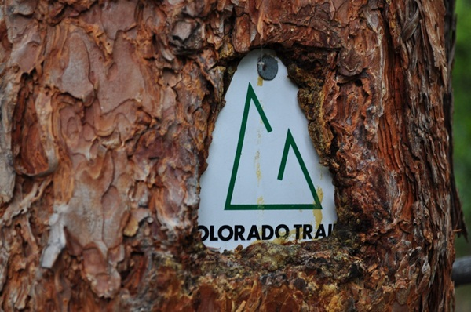

**Expedition Itinerary**

**Friday, August 10, 2012**

-8:00 am-5:00 pm Move in to the Residence Halls

-Dinner available in Slate Café

-7:30 pm Floor Meeting to prepare packing for next day and expectations for early arrival in the residence halls

**Saturday, August 11, 2012**

-7:30 am – 9:00 am Breakfast Slate Cafe

-Mid Morning Prep for the experience, organize personal equipment.

-11-12:30 am Lunch Slate Café

-1:00 pm: Meet at the Maple Hall Courtyard with all your personal equipment for the experience

-Welcome! Meet the residence on the floor and Student Trip Leaders and Professional Staff from the ORC

Prepare for your Backpacking and Summit experience

Packing and familiarize yourself with the equipment and supplies

Logistics

-Dinner @ Lions Park

-Nights stay at Mines either camping or in Residence Hall (TBD)

**Sunday, August 12, 2012**

-Wake up and be ready for Breakfast 6:30 am

-Departure 8:00 am from Mines to the backpacking departure point in Leadville, CO to start your adventure.

-Backpack a portion of the Colorado Trail and set up camp for the night.

**Monday and Tuesday, August 13 & 14, 2012**

-Depart your campsite and hike to the next destination. Mileage is between 4 to 8 miles a day. The Trip Leader Facilitators will inform you of your schedule during these days.

**Wednesday, August 15, 2012**

-Wake up early for an alpine start to summit high peak

-Return to campsite and gather up backpacking equipment, hike the remaining portion to vehicles.

-Return to group campsite closer to Golden

-Closure activities

-Prepare for High and low Ropes course following day

**Thursday, August 16, 2012**

-Arrive at Ropes course by 8 am Genesee Park, CO

-Meet remaining residents from the floor

-High and Low Ropes course all day

-Return to Mines by 4 pm for New Student Orientation

**Friday-Monday, August 17-20, 2012**

-New Student Orientation

**Tuesday, August 21, 2012**

**-School starts enjoy your first year at the Colorado School of Mines**

**Equipment List**

**What to Pack? Clothes and personal items you must bring**

Below you will see a number in front of the clothing, Think of it as 1 set of clothing you are wearing and 2 you are packing. Please limit the amount of items you bring because you will be carrying them. **PLEASE, NO COTTON MATERIALS**, they will not dry. Pack quick-dry, light-weight synthetics materials only. If you have any questions about this list, please do not hesitate to contact us at the Outdoor Recreation Center. In Leadville Colorado in August the average high temperature during the day is 68 degrees and the average low temperature is 38 degrees.

**Mandatory Items**

* 2-pair of quick dry shorts (1 you wear and 2 you pack)
* 3-Pair of quick dry socks
* 1-Pair of liner socks
* 2-Quick dry T-Shirts
* Underwear and Sports Bras (amount is up to you, but pack very light)
* 1-Quick dry long sleeve shirt
* 1-Pair of quick dry pants
* 1-Lightweight fleece jacket or pullover
* 1-Lightweight Fleece pants (For the chill and bugs)
* 1-Bandanna
* 1-Rain Jacket
* 1-Rain Pants
* 1-Lightweight Quick dry towel
* 1-Pair Sunglasses
* 1-Hat/Visor for sun
* 1-Pair light gloves for warmth
* 1-Warm hat for warmth
* Lip Balm with SPF sun protection
* Sunscreen SPF 30+(sweat proof)
* Bug Spray (30% DEET for it to work)
* Toothbrush and Toothpaste
* Hair Ties for long hair
* Contact materials/glasses/retainer strap (to keep them on your head)/hard sided case for glasses if needed
* Medicine as needed
* 1-travel pack of UNSCENTED baby wipes (Unscented because of animal attraction)
* 1-Roll Toilet Paper in quality ziplock bag
* Feminine products as needed (even if you are not on your cycle please bring some)
* Hydration System: A) 2-32 oz. Nalgenes (hard sided) B)1-32 oz. Nalgene (hard sided) & at least 1 liter camelback or larger
* Camera with extra batteries and memory card
* 2-Trash bags for waterproofing clothes and sleeping bag
* 5 to 10-One Gallon QUALITY freezer zip lock bags
* Small Journal
* Pen/writing utensil
* Light weight bowl (with lid), cup, and eating utensil
* Identification and insurance card
* A tiny amount of money for gas station stops on the way up and back
* 1-Pair of Broken in Hiking Boots or Trail Shoes (MUST BE BROKEN IN!!)
* 1-Pair of close toed sandals with heal strap for camp (Please no flip flops or shoes that do not stay on your foot)
* Watch with an alarm

**What Mines will provide**

**(you may be able to bring your own equipment for some items, see below)**

* Backpacks (if you have your own please feel free to bring it, 65+ liter)
* Sleeping Bags (if you have your own please feel free to bring it, 15 to 20 degree bag)
* Sleeping Pads (if you have your own please feel free to bring it, please keep it light weight & packable)
* Headlamp (if you have your own please feel free to bring it, please bring extra batteries that it needed)
* Trekking Poles (if you have your own please feel free to bring them)
* Food and Snacks (We will cater to dietary needs and restrictions, however please inform the Director on the application, also you know your body best and what it needs for energy, if you wish to bring supplemental snacks please do so)

For the remaining items please do not bring them, we will be supplying these items.

* Tents
* Hand Sanitizer
* Biodegradable camping soap
* Stoves and Fuel
* Cookware
* Cooking Utensils
* Water Dromedaries
* Chlorine/Iodine drops for water treatment (if you have a sensitivity to chlorine or iodine please contact the Director of the ORC prior to August 6, 2012 to ensure your needs can be met).
* First Aid Kits
* Transportation from Mines and back

**Optional Items**

**(Remember if you bring it, you carry it)**

* Summit Pack: Squashes and packs into the size of a softball (our backpack lids turn into day pack and can be an option to summit with, without extra weight, but some prefer a larger summit pack)
* Supplemental Snacks if you need or want them to fuel your body (We are providing snacks, but you know your body best and what it may need)
* Empty Pillow case/stuff sack for pillow making material
* Multi-tool/pocket knife
* Extra Batteries/SD card for camera if needed
* Blister Kits/Moleskin
* Binoculars
* Gaitors (The ORC can provide some of these if wanted, but not for everyone)
* Brush or comb
* Small stuff sacks for organizing items

**ITEMS NOT ALLOWED**

* Cell phones, IPODS, MP3 player or ANY Technology based entertainment
* WEAPONS
* Drugs
* Alcohol
* Tobacco Products
* Glass materials for breaking purposes
* ANYTHING SCENTED because of wild animals and IT Attracts bugs (Deodorant, make up, lotion etc)
* New Hiking boots (UNLESS broken in)

**How to Layer (Examples)**

Sleeping Layer (depends on if you are a warm or cold person)

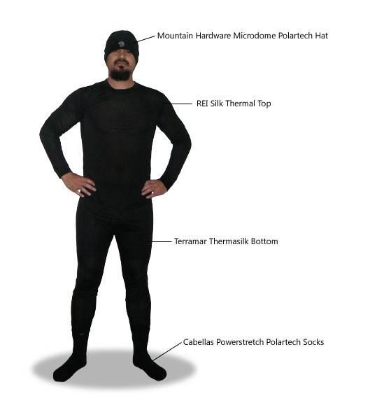

Warm Hiking

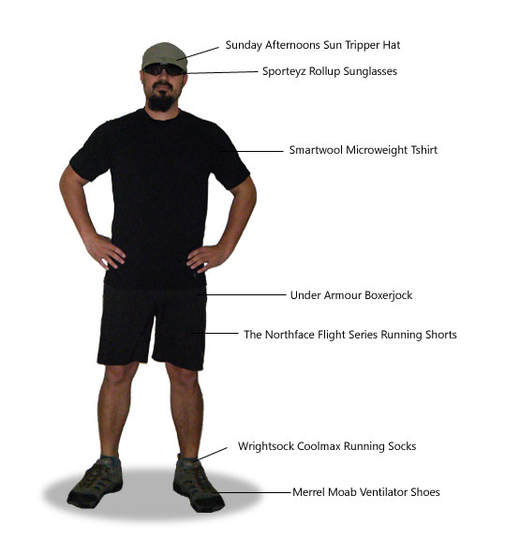

Colder Hiking

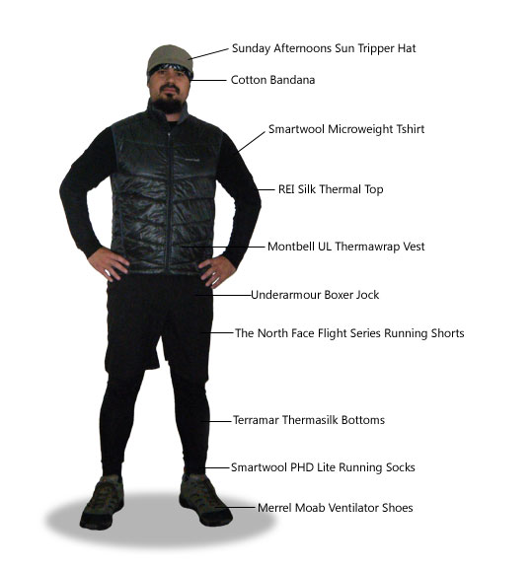

Rain Hiking (No umbrella)

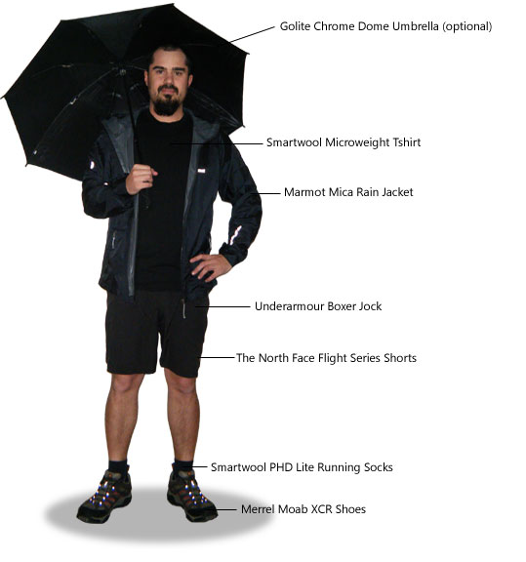

**Directions to Mines**

**Driving directions from Denver International Airport and/or from I-25**: Take I-70 west, exit Highway 58 to Golden. Exit Washington Street and turn left to enter into downtown Golden. Turn right on 13th Street and left on Illinois St to enter campus.

**From Denver**: Take 6th Avenue and head west into Golden. Turn right on 19th Street. Turn left on Illinois Street to enter campus.

**From C-470, I-70, or Western Slope**: Head east to 6th Avenue. Follow the directions above from 6th Avenue.

**From Boulder**: Take Highway 93 into Golden. Turn left onto 19th Street. Turn left on Illinois St Street to enter campus.

**Once on campus…**

1. Follow Illinois St to 18th Street.
2. Depending on the direction you came you would take a left or a right into the parking area for Maple Hall
3. You will then be in Parking lot E.
4. Participants should take all of their belongings and themselves through the Front Entrance Doors into Maple Hall and proceed to the front desk. Front desk staff will direct you on how to Check-In. The main doors are on Maple St.

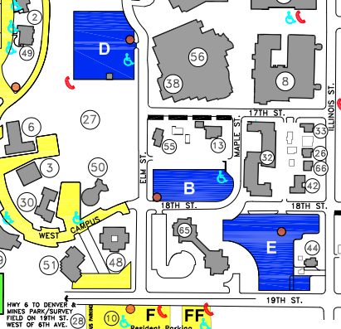



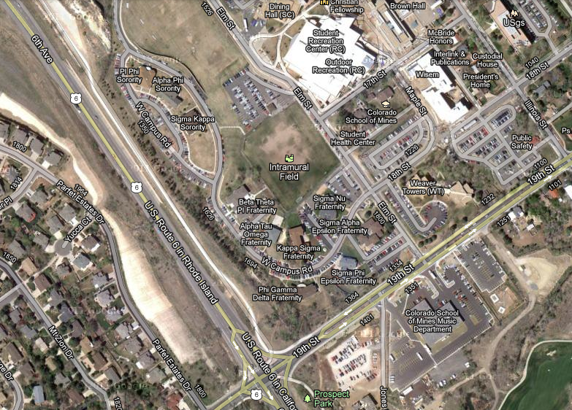

**PARKING**

**MAPLE HALL**

**Parking Permits**

Please go to <http://inside.mines.edu/Student-Freshmen_1>

This website discusses the process of gaining a parking permit for the fall of 2012-13.

Also other parking information, <http://www.mines.edu/MapsDirectionsParkingInfo>

**Additional Information**

**Cancellation and Refund Policy**

1. If this activity is cancelled for any reason by CSM ORC (i.e. weather, insufficient registration, etc.) you will receive a full refund.
2. If you must cancel, you must do so on or before July 20, 2012
3. If a participant cancels after July 20, 2012 you will be refunded **IF** we can find a participant to fill the spot. If we are unable to find a participant you **WILL NOT** receive a refund.

**Registration Deadline**

The deadline for registration is first come first serve. The final day to register is July 20, 2012. We have only two expeditions going, each with limited space. Please register quickly as our experiences tend to fill quickly.

**Dietary Needs and Food Information**

All food is provided on Mines campus and at the expedition destination. Food is not provided while on route to the destination. Participants may want to bring additional money for purchases at rest stops.

If you have specific dietary needs and failed to indicate this information on the registration form, please contact the Director of the Outdoor Recreation Program at 303-273-3907, so necessary arrangements can be made. Requests must be made by August 6, 2012 to ensure your needs can be met.

**Moving On Campus**

Residence Life is opening Maple hall and the Outdoor Recreation Floor one-day prior to the beginning of the experience. Food will be provided for Dinner on the 11th of August and Breakfast and Lunch on August 12. Please prepare accordingly.

**Other**

It is the participant’s responsibility to let family and friends know that they will be out of communication reach during the experience (August 12 @ 1 pm until August 17 @ 5 pm). If there are family emergencies they must call Amy Henkelman at (303) 384-3537. She will know how to get in touch with the teams in the field.

Participants are not allowed to drive themselves to and from the trailhead. This is a group experience and the participant must be with the group, in school vehicles for the entirety of the program. The university is liable if participants drive themselves.

**If you have further questions about your expedition, please feel free to contact the Director of the Outdoor Recreation Center at 303-273-3907.**

**We look forward to seeing you this**

**Summer and into the fall!**