HW #24

First Mentioned: Thursday, April 9, 2009
Statement Posted: Friday, April 10, 2009
Due: Friday, April 17, 2009

Fugacity coefficient can be written as:

(a) Verify the equation (2).

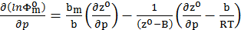
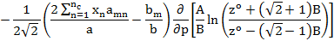

(2)

(b) Verify the equation (3).

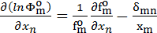
(3)

(c) Evaluate 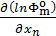 for 3-component system; n=1, 2, 3. Use equation #1 and expand the partial derivatives until you reach constants. Remember that , , B, A, and are all functions of the compositions .

