EENG 393 – ICE field session Power Supply Review By:
For:

Complete this worksheet for each schematic and layout reviewed. When you complete this worksheet, save it as “Engineering Review by <your name>” and upload to the reviewees Google drive folder.

Schematic Review

Start by reviewing the power supply schematic by opening the schematic in EAGLE CAD. Then make a screen capture of the entire schematic using Shift+PrtSc or the Snipping Tool. Paste the schematic into a image editing tool that you are comfortable with. In the image editing program, annotate the captured image with text pointing out any issues in the list below. Then paste this annotated schematic back into this document when done.

- Run the ERC – note any non-standard errors below
  - Ignore warning “POWER pin XYZ connected to XYZ”
  - Ignore warning “Part XYZ has no value”
  - Ignore warning “Part XYZ has uninvoked date D with unconnected inputs pin XYZ”
  - Ignore warning about unconnected pin on heat sink
- Review component connections – wires should be straight or contains the least number of bends possible,
- Grab and “shake” all components – improperly connected components will “come loose”

Paste annotated schematic below

Layout Review

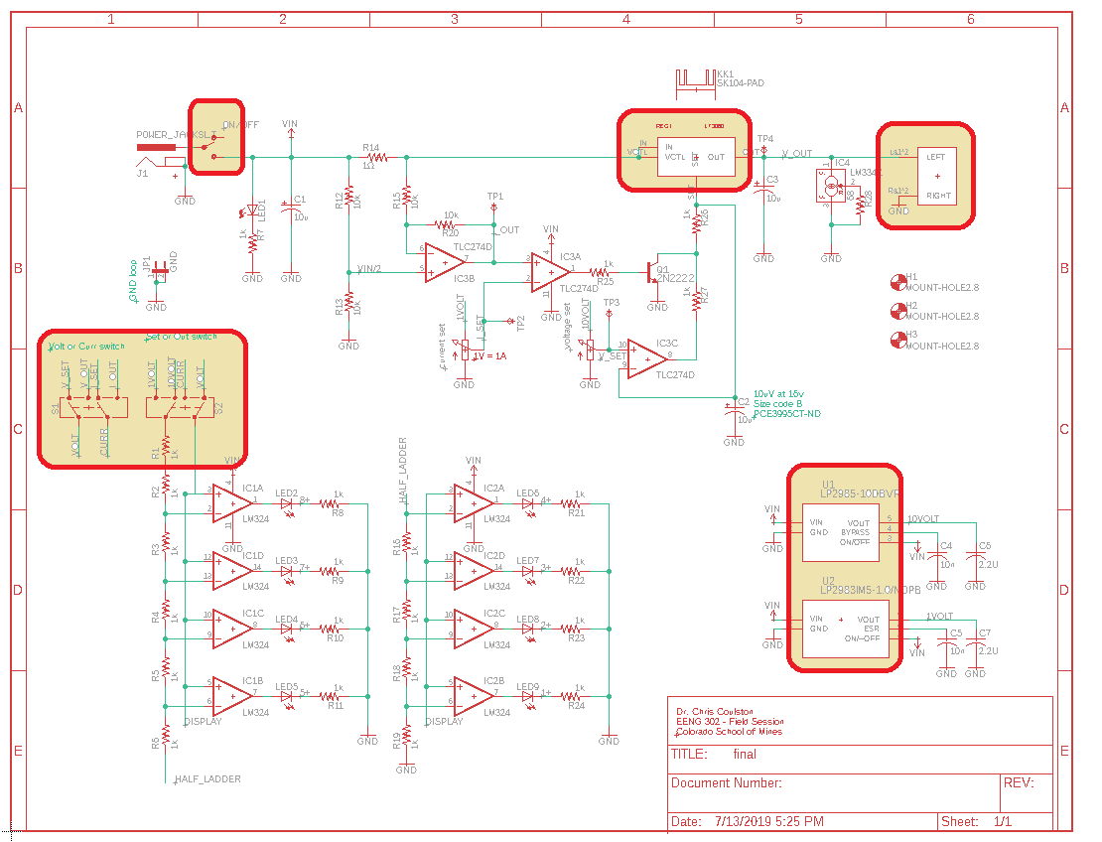

Next review the power supply layout by opening the layout in EAGLE CAD. Then make a screen capture of the entire layout using Shift+PrtSc or the Snipping Tool. Paste the layout into an image editing tool that you are comfortable with. In the image editing program, annotate the captured image with text pointing out any issues in the list below. Then paste the annotated layout back into this document when done.

- Check the footprints of the shaded components in the schematic above,
- Run DRC and report any issues,
- Check configuration of the DPDT switches controlling the VU meter input,
- Check the inverting and non-inverting inputs of all 11 op-amps,
- Grab and “shake” all components – improperly connected components will “come loose”

Paste annotate layout below:

While reviewing the layout, check the following

Components | Pass/Fail + Comments
Place the following components on the edge of the board:
- Heat sink
- On/Off switch
- Power connector
- Spring terminal block
Have switch near power connector
Have LED near switch
Place heat sink away from controls
Put Iset and Vset pots nearby in a row or column
Place components on 50 mil grid
Align adjacent resistors in rows and column
Put mounting holes near corners
Board
Board dimensions should be on 0.1" grid
Make the board outline as small as reasonably possible
Center mounting holes on 0.1" grid
Place mounting holes symmetrically
Route wires on 10 mil grid
Wires
Avoid routing wires between close pads
Avoid 90° bends in wires
Avoid routing on the bottom layer
Use ground via's when convenient
Copper pours
Copper pour ground on the bottom plane
Copper pour power on the top plane
Exactly align top and bottom pours
Silk screen
Uniform font and size for part designators
Uniform location for part designators on similar parts
Add "on"/"off" text near the switch with correct orientation
Add "CURR" next to Iset pot and "VOLT" next to Vset pot
Add polarity, voltage and current details to DC power input
Add instructions for VU meter switch settings

Note any other suggestions below.

